OILCONDITION MONITORING REPORT

ENGINE PARTICULARS (Information provided by the customer)
 | Port Main Engine | Stbd Main Engine
Make: | MAN
Model: | B&W CXZ 8L20/27
Sr. No’s: | 10463 | 10464
Date sampling: | 12 Aug 25 | 16 Aug 25
Sampling point: | Before Lub oil filter
Sampling Method: | Extraction
Type of Lubricant : | Shell Gadinia S3 40
System Capacity: | 210 Ltrs

RUNNING HRS DETAILS (Information provided by the customer)
 | Port Main Engine | Stbd Main Engine
Sample ID | M010660 | M010661
Oil Running Hours | 100.00 | 500.25
After Major Overhaul Running Hours | 8726.35 | 2011.25
Total Running Hours of the Machinery | 29230.20 | 29052.05

ANALYSIS RESULTS

Description | Method | Fresh Oil  (As per OEM datasheet) | Uncertainty  (K=2) | Port Main Engine | Stbd Main Engine
 |  |  |  | M010660 | M010661
Viscosity@40ºC (cSt) | ASTMD445 | 128.0 | 0.006 | 138.48 | 136.93
Viscosity@100ºC (cSt) | ASTMD445 | 13.70 | 0.005 | 15.30 | 15.73
Viscosity Index | ASTMD2270 | 103 | N/A | 113.20 | 119.89
Water content % | ASTM D95 | < 0.2 | 0.082 | < 0.1 | < 0.1

Elemental Concentration as per ASTM D 5185 (ppm)
Element | Maximum Permissible  Limit | Fresh Oil Sample | Uncertainty  (K=2) | Port Main Engine | Stbd Main Engine
 |  |  |  | M010660 | M010661
Fe | 80 | <1.000 | 0.15 | 5.114 | 5.895
Cr | 10 | <1.000 | 0.18 | <1.000 | 1.126
Si | 15 | <1.000 | 0.17 | <1.000 | <1.000
Al | 20 | <1.000 | 0.28 | 1.762 | <1.000
Pb | 20 | <1.000 | 0.13 | <1.000 | <1.000
Cu | 25 | <1.000 | 0.17 | 3.195 | 11.200
Sn | 10 | <1.000 | 0.20 | <1.000 | <1.000
Ni | 10 | <1.000 | 0.08 | <1.000 | <1.000

TREND ANALYSIS WITH PREVIOUS REPORTS

 |  | Fresh Oil Sample | Port Main Engine
 |  | Fresh Oil Sample | S/I-  M000019 | S/I-  M000386 | S/I-  M000386 | S/I-  M001659 | S/I-  M002460 | S/I-M002848 | S/I-  M002957 | S/I-M003360 | S/I-  M003944 | S/I-M004538 | S/I-  M004656 | S/I-  M005158 | S/I-  M005231 | S/I-  M005261 | S/I-  M005886
Oil Running Hrs |  | - | 134.25 | 139.00 | 102.30 | 500.05 | 242.15 | 485.05 | 94.35 | 476.15 | 436.45 | 490.40 | 145.15 | 252.35 | 298.55 | 298.55 | 06.50
T/R/H of Machinery |  | - | 22240.35 | 23004.40 | 23950.30 | 24856.10 | 25102 | 25344.50 | 25453.55 | 25976.55 | 26440.30 | 26988.40 | 27133.55 | 27241.15 | 27287.35 | 27287.35 | 27294.55
Basic Properties
Viscosity@40ºC (cSt) |  | 104.05 | N/C | N/C | 98.01 | 98.13 | 96.02 | 95.00 | 97.11 | 102.99 | 102.60 | 101.98 | 95.83 | 102.05 | 100.47 | 100.14 | 93.22
Viscosity@100ºC (cSt) |  | 11.5 | N/C | N/C | 11.04 | 11.23 | 11.15 | 11.41 | 11.59 | 11.40 | 11.66 | 11.31 | 10.81 | 11.8 | 11.54 | 11.99 | 11.25
Viscosity Index |  | 97 | N/C | N/C | 97.07 | 99.94 | 101.47 | 107.46 | 107.52 | 101.54 | 101.25 | 101.98 | 96.00 | 104.27 | 102.05 | 109.98 | 107.28
Total Base No.(mgKOH/g) |  | 7.85 | N/C | N/C | 7.37 | 5.82 | N/C | N/C | 6.45 | N/C | N/C | N/C | N/C | N/C | N/C | N/C | N/C
Water content(%) |  | <0.2 | N/C | N/C | < 0.1 | < 0.1 | N/C | N/C | < 0.1 | N/C | N/C | N/C | N/C | N/C | N/C | N/C | N/C
Flash Point(ºC) |  | 240 | N/C | N/C | 214 | N/C | N/C | N/C | 200 | N/C | N/C | N/C | N/C | N/C | 0.7 | N/C | N/C
Elemental Concentration as per ASTM D5185(ppm)
Element | Max. Permissible Limit
Fe | 80 | < 1.000 | 11.620 | 1.890 | 4.232 | 3.310 | 5.607 | 3.973 | 2.182 | 6.431 | 4.011 | 7.056 | 16.908 | 14.886 | 14.573 | 15.115 | 4.910
Cr | 10 | < 1.000 | 2.289 | <1.000 | 1.139 | <1.000 | <1.000 | 1.150 | <1.000 | 1.888 | 1.066 | 1.582 | <1.000 | 1.350 | 1.662 | 1.904 | 1.599
Si | 15 | < 1.000 | 7.571 | 2.963 | 5.912 | 5.456 | 6.665 | 4.169 | 1.234 | 4.805 | <1.000 | 1.257 | <1.000 | 1.722 | 2.939 | 9.534 | 7.922
Al | 20 | < 1.000 | <1.000 | <1.000 | <1.000 | <1.000 | <1.000 | <1.000 | <1.000 | 2.542 | <1.000 | <1.000 | <1.000 | <1.000 | <1.000 | <1.000 | 2.010
Pb | 20 | < 1.000 | 4.379 | <1.000 | <1.000 | <1.000 | <1.000 | 1.069 | 2.551 | <1.000 | <1.000 | <1.000 | 5.522 | 4.407 | 4.247 | 4.313 | 3.576
Cu | 25 | < 1.000 | 10.739 | <1.000 | 1.224 | <1.000 | 2.297 | 1.327 | <1.000 | 1.575 | 1.994 | 2.874 | 4.436 | 101.892 | 102.153 | 125.877 | 53.931
Sn | 10 | < 1.000 | <1.000 | <1.000 | <1.000 | <1.000 | <1.000 | <1.000 | <1.000 | <1.000 | <1.000 | <1.000 | <1.000 | <1.000 | <1.000 | <1.000 | 1.554
Ni | 10 | < 1.000 | <1.000 | <1.000 | <1.000 | <1.000 | <1.000 | <1.000 | <1.000 | <1.000 | <1.000 | <1.000 | <1.000 | <1.000 | 1.325 | N/C | N/C

 |  | Fresh Oil  Sample | Port Main Engine
 |  | Fresh Oil  Sample | S/I-  M006460 | S/I-  M006461 | S/I-  M006462 | S/I-  M006501 | S/I-  M006606 | S/I-  M007158 | S/I-  M007459 | S/I-  M007770 | S/I-  M008153 | S/I-  M008594 | S/I-  M009164 | S/I-  M009285 | S/I-  M009911 | S/I- M010152 | S/I- M010291 | S/I- M010660
Oil Running Hrs |  | - | 12.25 | 12.25 | 12.25 | 20.15 | 50.0 | 249.35 | 350.05 | 50.00 | 253.35 | 445.45 | 500.00 | 216.05 | 500.00 | 150.00 | 350.00 | 100.00
T/R/H of Machinery |  | - | 27307.20 | 27307.20 | 27307.20 | 27315.40 | 27344.55 | 27544.30 | 27645.00 | 27753.30 | 27957.05 | 28149.15 | 28203.30 | 28419.35 | 28703.30 | 28853.30 | 29053.30 | 29230.20
Basic Properties
Viscosity@40ºC (cSt) |  | 128.0 | 126.29 | 129.39 | 124.04 | 127.21 | 121.65 | 121.31 | 145.78 | 120.81 | 117.60 | 114.13 | 117.02 | 131.01 | 138.19 | 131.20 | 147.44 | 138.48
Viscosity@100ºC (cSt) |  | 13.70 | 13.48 | 13.84 | 13.36 | 13.41 | 13.06 | 12.92 | 16.89 | 13.47 | 12.99 | 12.78 | 13.13 | 14.54 | 16.62 | 14.28 | 18.39 | 15.30
Viscosity Index |  | 103 | 101.79 | 103.56 | 101.55 | 102.56 | 100.68 | 99.16 | 99.16 | 107.32 | 103.88 | 102.78 | 106.68 | 110.94 | 129.15 | 107.46 | 139.84 | 113.20
Total Base No.(mgKOH/g) |  | 10.48* | N/C | N/C | N/C | N/C | N/C | N/C | N/C | N/C | N/C | N/C | N/C | N/C | N/C | N/C | N/C | N/C
Water content (%) |  | <0.2 | < 0.1 | < 0.1 | N/C | N/C | N/C | N/C | <0.1 | <0.1 | N/C | N/C | N/C | N/C | <0.1 | <0.1 | <0.1 | <0.1
Flash Point (ºC) |  | 230 | N/C | N/C | N/C | N/C | N/C | N/C | 210 | 210 | N/C | N/C | N/C | N/C | N/C | N/C | N/C | N/C
Insoluble (g) |  | 2.5 | 0.14 | 0.12 | 0.13 | N/C | N/C | N/C | N/C | N/C | N/C | N/C | N/C | N/C | N/C | N/C | N/C | N/C
Elemental Concentration as per ASTM D5185 (ppm)
Element | Max. Permissible Limit
Fe | 80 | <1.000 | 3.421 | 3.166 | 5.129 | 2.759 | 4.423 | 4.573 | 8.128 | 5.119 | 4.818 | 3.519 | 7.964 | 6.154 | 6.945 | 5.508 | 5.245 | 5.114
Cr | 10 | <1.000 | <1.000 | <1.000 | <1.000 | <1.000 | <1.000 | <1.000 | <1.000 | <1.000 | <1.000 | <1.000 | <1.000 | <1.000 | <1.000 | <1.000 | <1.000 | <1.000
Si | 15 | <1.000 | 7.145 | 7.391 | 10.624 | 4.021 | 5.613 | 2.874 | 6.589 | 10.325 | <1.000 | 1.205 | <1.000 | <1.000 | <1.000 | <1.000 | <1.000 | <1.000
Al | 20 | <1.000 | <1.000 | <1.000 | 3.414 | <1.000 | 3.152 | <1.000 | <1.000 | <1.000 | <1.000 | <1.000 | <1.000 | <1.000 | 1.089 | <1.000 | <1.000 | 1.762
Pb | 20 | <1.000 | 1.000 | <1.000 | 4.147 | <1.000 | 1.212 | <1.000 | <1.000 | <1.000 | <1.000 | <1.000 | <1.000 | <1.000 | 1.203 | <1.000 | <1.000 | <1.000
Cu | 25 | <1.000 | 4.239 | 3.615 | 6.129 | 8.228 | 8.413 | 26.159 | 87.601 | 7.341 | 22.761 | 43.230 | 36.004 | 14.138 | 13.723 | 9.825 | 9.169 | 3.195
Sn | 10 | <1.000 | <1.000 | <1.000 | 3.391 | <1.000 | <1.000 | <1.000 | <1.000 | <1.000 | <1.000 | <1.000 | <1.000 | <1.000 | <1.000 | <1.000 | <1.000 | <1.000
Ni | 10 | <1.000 | <1.000 | <1.000 | <1.000 | <1.000 | <1.000 | <1.000 | <1.000 | <1.000 | N/C | <1.000 | <1.000 | <1.000 | <1.000 | <1.000 | <1.000 | <1.000

Stbd Main Engine
 |  | F. Oil Sample | S/I-M000020 | S/I-M000387 | S/I-M000924 | S/I-M001660 | S/I-M002461 | S/I-M002688 | S/I-M003268 | S/I-M003943 | S/I-M004539 | S/I-M004598 | S/I-M004599 | S/I-M004600 | S/I-M004657 | S/I-M004706 | S/I-M005159 | S/I-  M005224 | S/I-  M005887 | S/I-  M005888
Oil Running Hrs |  | - | 223.10 | 262.20 | 115.25 | 506.05 | 126.20 | 54.24 | 422.35 | 498.00 | 484.55 | 122.55 | 02.05 | 00.45 | 10.00 | 34.15 | 97.00 | 114.30 | 00.45 | 00.45
T/R/H of Machinery |  | - | 21695 | 22480 | 23313 | 24295 | 24515.05 | 24703.20 | 25807.40 | 26307.25 | 26800.05 | 26923.00 | 26925.0 | 26925.50 | 26936.05 | 26960.20 | 27023.05 | 27040.35 | 27041.20 | 27041.20
Basic Properties
Viscosity@40ºC (cSt) |  | 104.05 | N/C | N/C | 98.87 | 101.74 | 94.24 | 97.08 | 104.47 | 106.12 | 98.67 | 96.57 | 60.45 | 99.45 | 97.41 | 98.51 | 103.46 | 104.24 | 103.16 | 95.09
Viscosity@100ºC (cSt) |  | 11.5 | N/C | N/C | 11.63 | 11.31 | 11.02 | 10.85 | 12.20 | 11.78 | 10.94 | 11.78 | 10.26 | 11.65 | 10.94 | 11.51 | 11.21 | 11.38 | 12.07 | 11.49
Viscosity Index |  | 97 | N/C | N/C | 105.72 | 96.82 | 101.71 | 95.05 | 107.66 | 98.91 | 94.54 | 111.55 | 158.40 | 105.27 | 96.16 | 96.59 | 93.12 | 94.94 | 107.27 | 108.69
Total Base No.(mgKOH/g) |  | 7.85 | N/C | N/C | 7.22 | 6.14 | N/C | 5.77 | 6.02 | N/C | N/C | N/C | N/C | N/C | N/C | N/C | N/C | N/C | N/C | N/C
Water content (%) |  | < 0.2 | N/C | N/C | < 0.1 | < 0.1 | N/C | < 0.1 | < 0.1 | N/C | N/C | N/C | 0.2 | N/C | N/C | N/C | N/C | 1.20 | 0.3 | 0.4
Flash Point (ºC) |  | 240 | N/C | N/C | 212 | N/C | N/C | 195 | 180 | N/C | N/C | N/C | N/C | N/C | N/C | N/C | N/C | N/C | N/C | N/C
Element | Max. Permissible Limit
Fe | 80 | <1.000 | 15.732 | 7.684 | 6.791 | 9.471 | 4.361 | 5.237 | 3.451 | 5.856 | 8.963 | 9.205 | 6.869 | 23.606 | 17.284 | 15.123 | 22.693 | 89.557 | 72.525 | 57.928
Cr | 10 | <1.000 | 2.703 | 1.379 | 1.366 | 2.176 | <1.000 | 1.074 | <1.000 | 1.308 | <1.000 | <1.000 | <1.000 | <1.000 | <1.000 | <1.000 | 1.879 | 2.984 | 1.255 | <1.000
Si | 15 | <1.000 | 6.486 | 3.448 | 6.629 | 5.815 | <1.000 | 2.941 | <1.000 | 1.026 | <1.000 | 1.433 | 1.846 | 2.808 | <1.000 | 2.139 | 2.739 | 4.953 | 13.108 | 13.316
Al | 20 | <1.000 | <1.000 | <1.000 | <1.000 | <1.000 | <1.000 | <1.000 | <1.000 | 2.092 | <1.000 | <1.000 | <1.000 | <1.000 | <1.000 | <1.000 | <1.000 | <1.000 | 3.817 | 2.574
Pb | 20 | <1.000 | 3.220 | <1.000 | <1.000 | <1.000 | 2.168 | <1.000 | <1.000 | 2.851 | 6.560 | 8.096 | 7.842 | 7.805 | 8.129 | 11.704 | 8.871 | 36.933 | 30.155 | 18.763
Cu | 25 | <1.000 | 6.670 | <1.000 | 1.229 | 1.098 | 1.835 | 1.545 | <1.000 | 2.527 | 15.055 | 15.810 | 9.988 | 12.560 | 23.850 | 6.208 | 18.560 | 124.286 | 83.866 | 81.045
Sn | 10 | <1.000 | <1.000 | <1.000 | <1.000 | <1.000 | <1.000 | <1.000 | <1.000 | <1.000 | 1.027 | <1.000 | <1.000 | <1.000 | <1.000 | <1.000 | 1.162 | 1.754 | <1.000 | <1.000
Ni | 10 | <1.000 | <1.000 | <1.000 | <1.000 | <1.000 | <1.000 | <1.000 | <1.000 | <1.000 | <1.000 | <1.000 | <1.000 | 1.256 | <1.000 | <1.000 | 1.111 | 1.325 | N/C | N/C

 |  | Stbd Main Engine
 |  | F. Oil Sample | S/I-  M005884 | S/I-  M005885 | S/I-  M005907 | F. Oil Sample | S/I-  M006463 | S/I-  M006464 | S/I-  M006465 | S/I-  M006502 | S/I-  M006607 | S/I-  M006607 | S/I-M007845 | S/I-  M008238 | S/I- M008595 | S/I- M009286 | S/I- M009912 | S/I- M010153 | S/I- M010578 | S/I- M010661
Oil Running Hrs |  | - | 00.45 | 00.45 | 00.00 |  | 14.38 | 14.38 | 14.38 | 21.45 | 50.00 | 230.15 | 504.30 | 250.00 | 350.05 | 500.00 | 506.35 | 151.15 | 351.15 | 500.25
T/R/H of Machinery |  | - | 27041.20 | 27041.20 | 270.41.20 | - | 27055.58 | 27055.58 | 27055.58 | 27063.05 | 27091.20 | 27271.35 | 27545.05 | 27795.05 | 27895.10 | 28045.05 | 28551.40 | 28702.55 | 28902.55 | 29052.05
Basic Properties
Viscosity@40ºC (cSt) |  | 104.05 | 93.73 | 93.65 | 94.32 | 128.0 | 127.13 | 127.36 | 124.24 | 128.19 | 124.76 | 118.06 | 104.28 | 126.23 | 122.50 | 130.94 | 137.81 | 129.83 | 135.18 | 136.93
Viscosity@100ºC (cSt) |  | 11.5 | 11.44 | 11.36 | 11.50 | 13.70 | 13.83 | 13.77 | 13.45 | 13.44 | 13.11 | 12.42 | 11.77 | 14.02 | 13.84 | 14.06 | 15.41 | 13.97 | 14.65 | 15.73
Viscosity Index |  | 97 | 109.88 | 108.59 | 110.05 | 103 | 102.36 | 101.64 | 102.87 | 101.25 | 98.43 | 95.59 | 100.91 | 109.07 | 108.45 | 104.91 | 115.16 | 104.83 | 108.32 | 119.89
Total Base No.(mgKOH/g) |  | 7.85 | N/C | N/C | N/C | 10.48* | N/C | N/C | N/C | N/C | N/C | N/C | N/C | N/C | N/C | N/C | N/C | N/C | N/C | N/C
Water content(%) |  | < 0.2 | N/C | <0.2 | N/C | <0.2 | N/C | < 0.1 | < 0.1 | N/C | N/C | N/C | N/C | N/C | N/C | N/C | < 0.1 | < 0.1 | < 0.1 | < 0.1
Flash Point (ºC) |  | 240 | N/C | N/C | N/C | 230 | N/C | N/C | N/C | N/C | N/C | N/C | 200 | N/C | N/C | N/C | N/C | N/C | N/C | N/C
Insoluble (g) |  | 2.5 | N/C | N/C | N/C | 2.5 | 0.14 | 0.13 | 0.12 | N/C | N/C | N/C | N/C | N/C | N/C | N/C | N/C | N/C | N/C | N/C
Element | Max. Permissible Limit
Fe | 80 | <1.000 | 8.954 | 9.276 | 6.271 | <1.000 | 14.565 | 12.568 | 15.015 | 20.012 | 16.355 | 16.213 | 23.874 | 8.526 | 6.765 | 9.179 | 8.250 | 4.243 | 7.827 | 5.895
Cr | 10 | <1.000 | <1.000 | <1.000 | <1.000 | <1.000 | <1.000 | <1.000 | <1.000 | <1.000 | <1.000 | <1.000 | 3.509 | 2.984 | <1.000 | 3.758 | 3.724 | <1.000 | 2.464 | 1.126
Si | 15 | <1.000 | 6.612 | 6.111 | 10.264 | <1.000 | 9.103 | 7.235 | 7.238 | 7.367 | 5.440 | 2.643 | 11.449 | 7.945 | 1.282 | <1.000 | 3.350 | <1.000 | <1.000 | <1.000
Al | 20 | <1.000 | <1.000 | <1.000 | <1.000 | <1.000 | 1.041 | <1.000 | 1.076 | <1.000 | 2.075 | <1.000 | 2.318 | 1.358 | 1.009 | <1.000 | 2.265 | <1.000 | 2.097 | <1.000
Pb | 20 | <1.000 | 2.993 | 3.702 | 5.501 | <1.000 | 1.361 | 1.631 | 1.497 | 1.326 | 1.761 | 1.752 | 1.942 | <1.000 | 1.136 | <1.000 | 1.078 | <1.000 | 1.951 | <1.000
Cu | 25 | <1.000 | 12.897 | 12.076 | 44.194 | <1.000 | 2.044 | 2.126 | 3.068 | 8.811 | 6.886 | 4.168 | 10.306 | 6.692 | 9.966 | 11.749 | 8.584 | 8.452 | 12.091 | 11.200
Sn | 10 | <1.000 | <1.000 | <1.000 | <1.000 | <1.000 | <1.000 | <1.000 | <1.000 | <1.000 | <1.000 | <1.000 | <1.000 | <1.000 | <1.000 | <1.000 | <1.000 | <1.000 | <1.000 | <1.000
Ni | 10 | <1.000 | N/C | N/C | N/C | <1.000 | <1.000 | <1.000 | <1.000 | <1.000 | <1.000 | <1.000 | <1.000 | <1.000 | <1.000 | <1.000 | <1.000 | <1.000 | <1.000 | <1.000

Wear Metals (Port M/E)
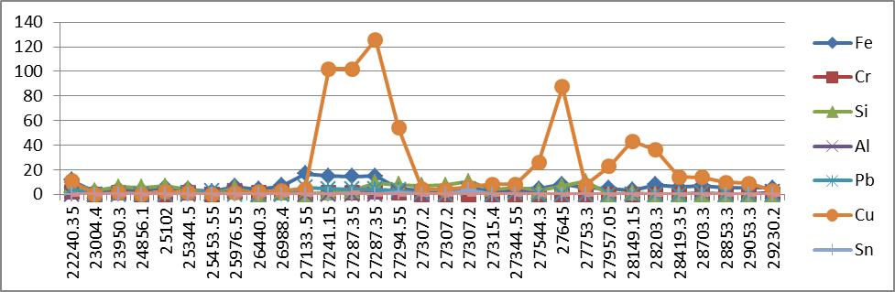
`

ppm

Total Running Hrs

Wear Metals (Stbd M/E)
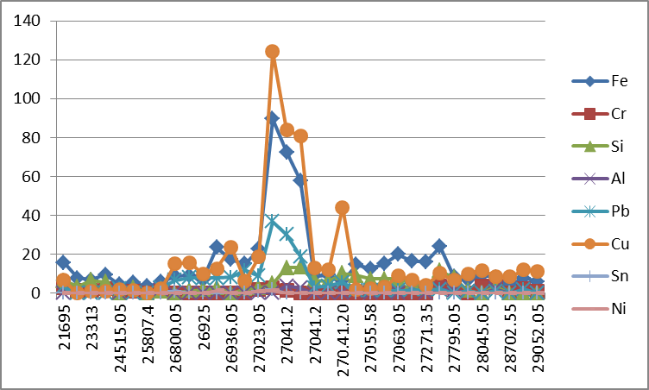
`

ppm

Total Running Hrs

Viscosity (Port M/E)
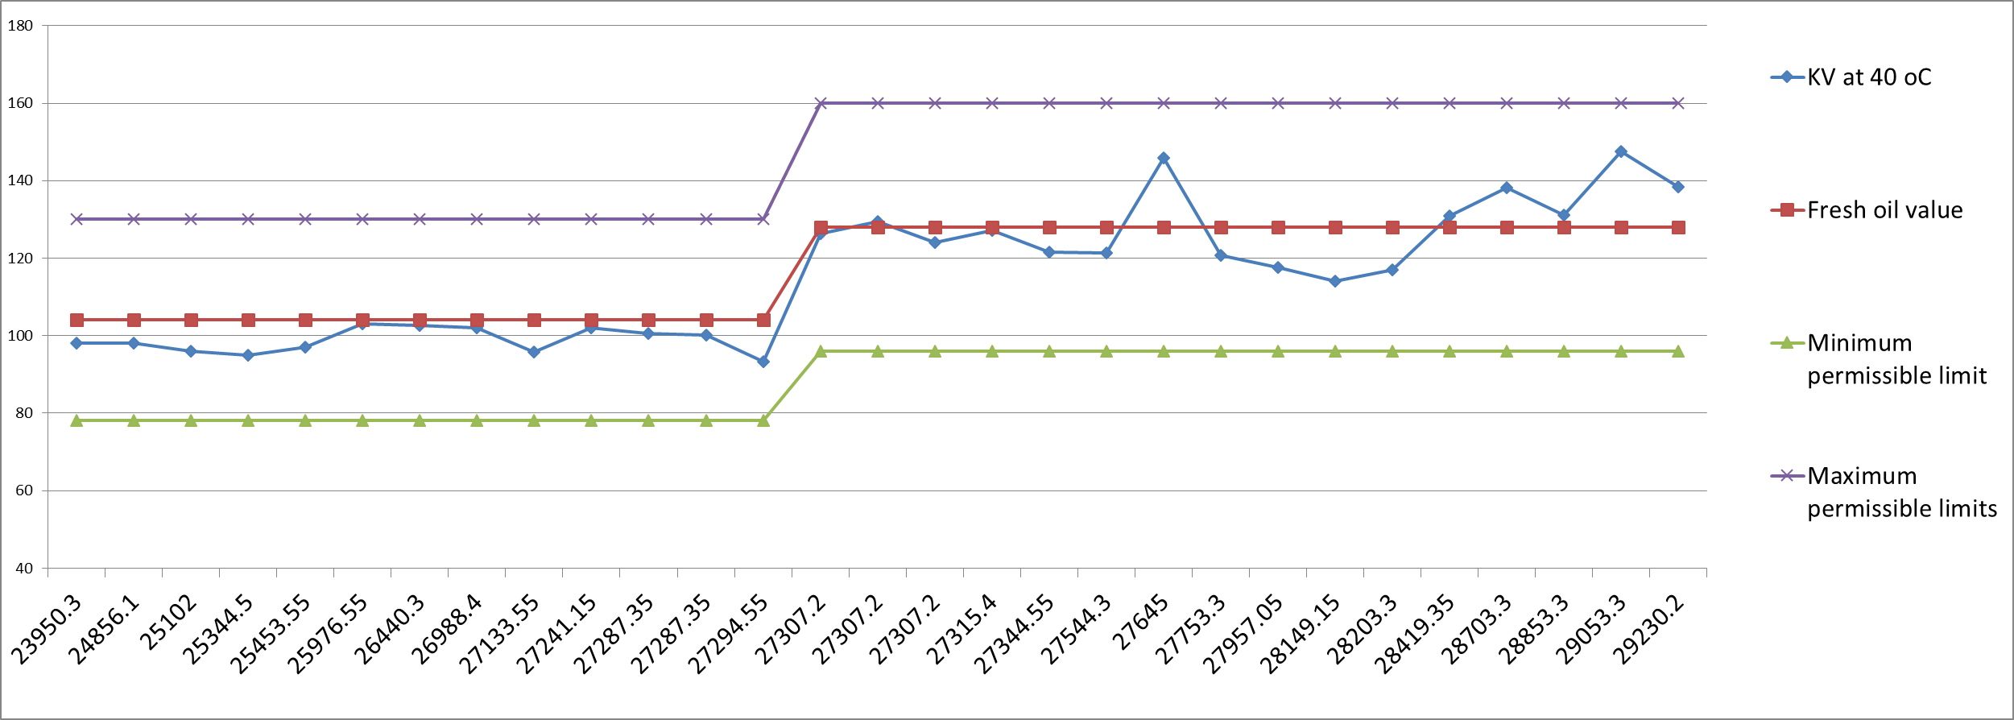
40⁰C 100⁰C
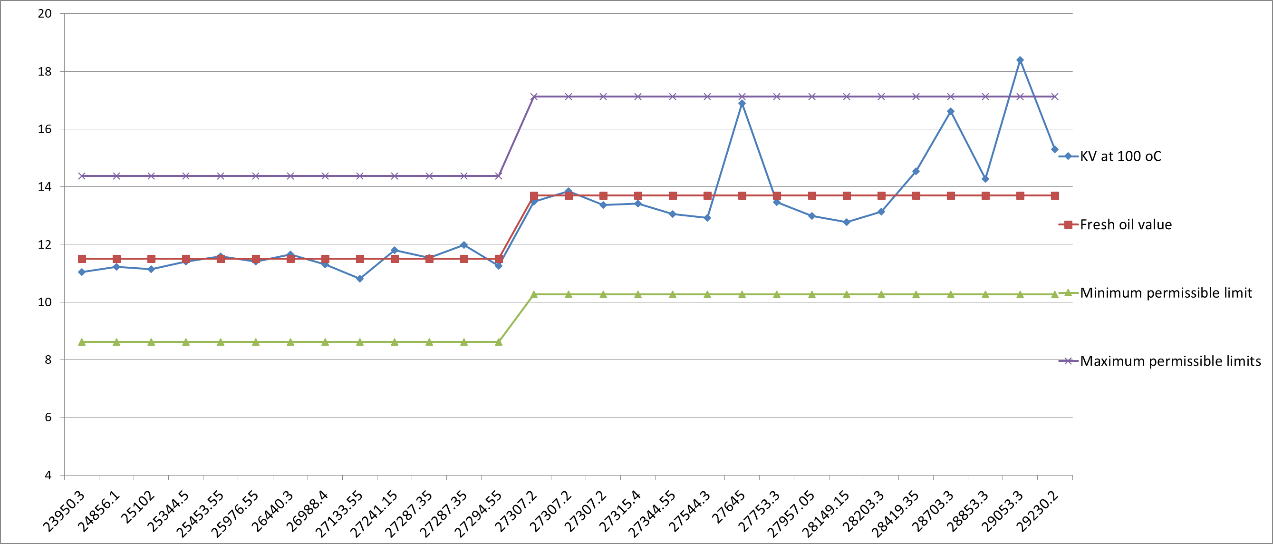

cSt
cSt

Total Running Hrs
Total Running Hrs

Viscosity (Stbd M/E)
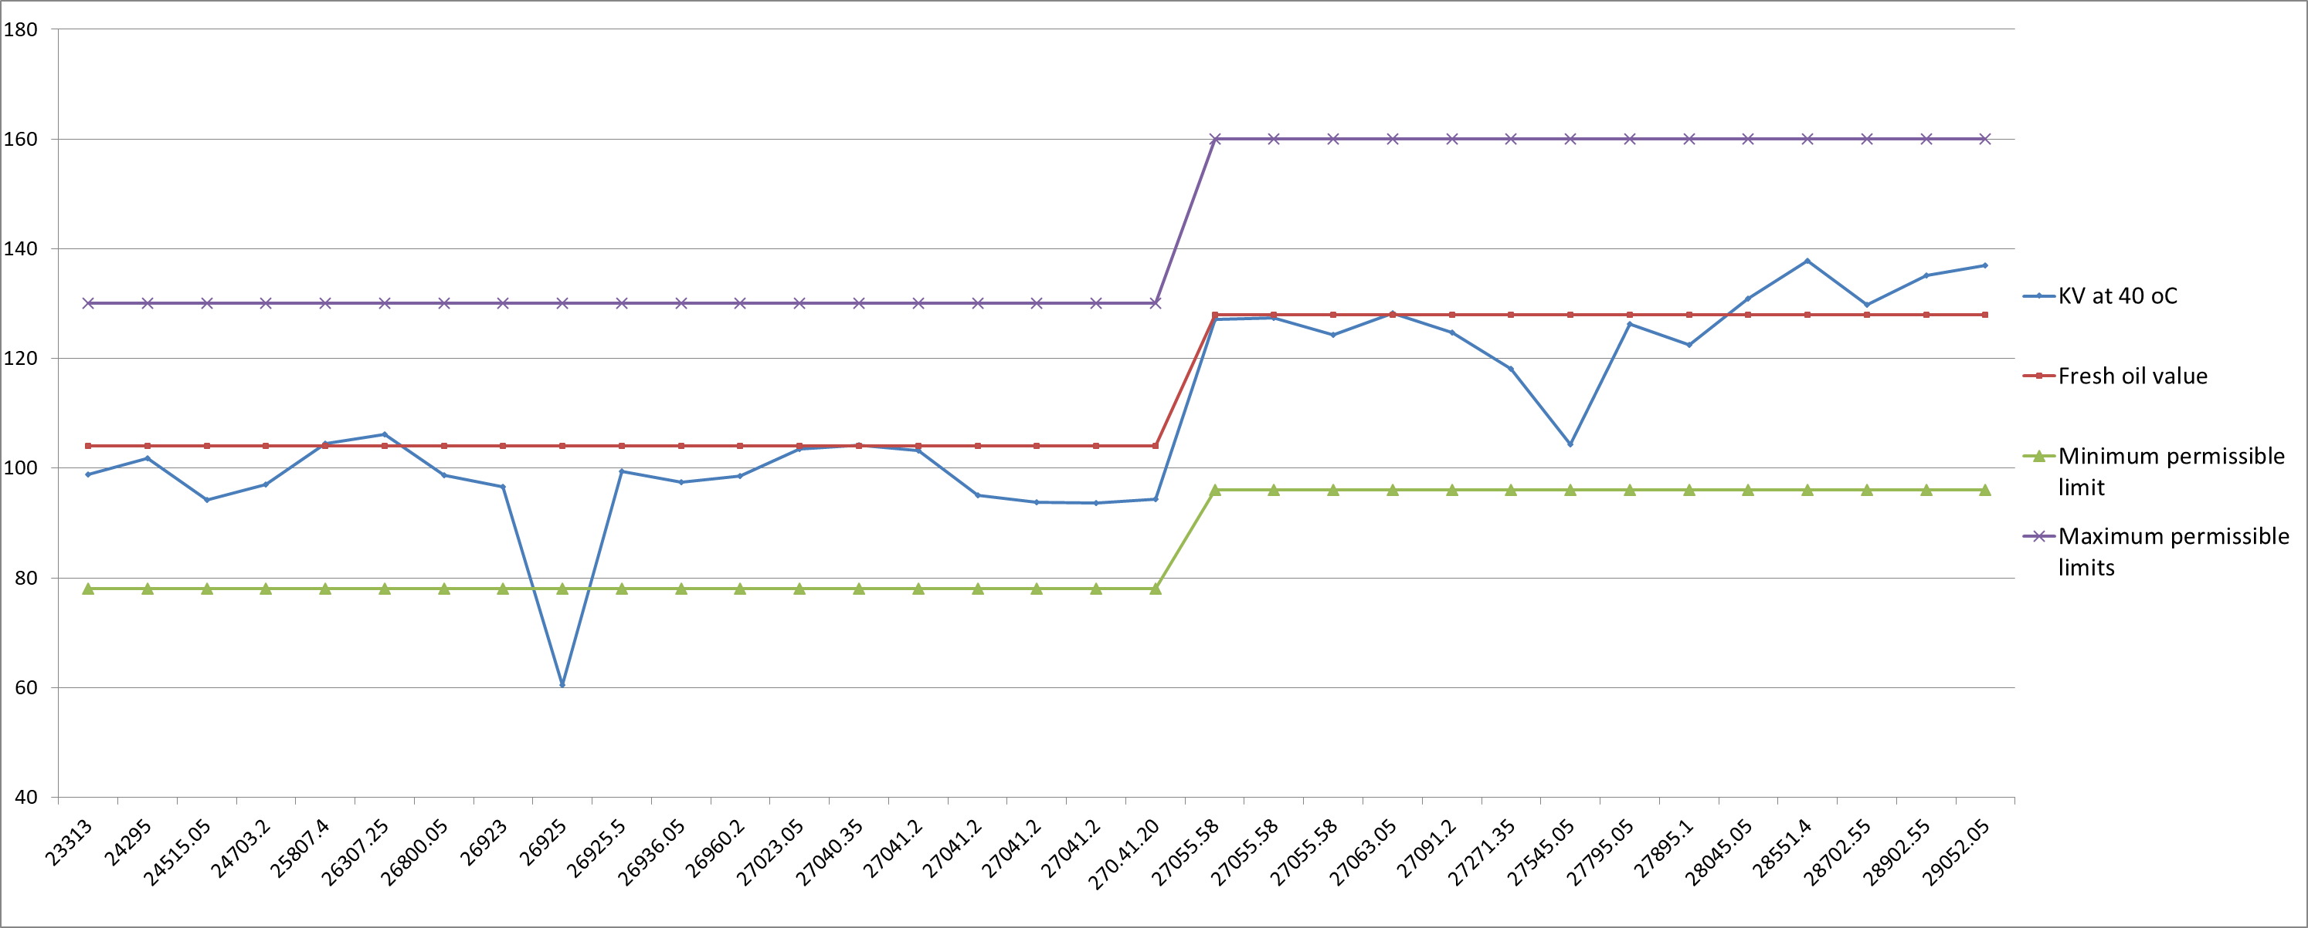
40⁰C 100⁰C
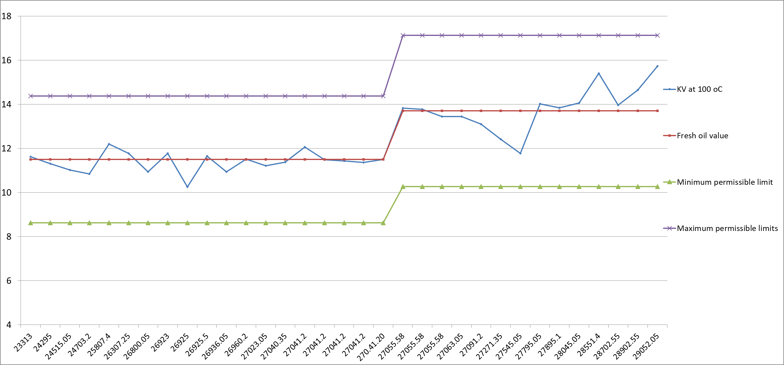

cSt
cSt

Total Running Hrs
Total Running Hrs

